**Shell Script Assignment**

1. Create a script named “myscript” in current directory to do the following.

a) display “hello user” – **echo “hello user”**

b) list files in current directory – **ls**

c) name of logged in user – **echo “Logged in user: $(whoami)”**

d) date – **echo “Current date: $(date)”**

2. Add execute permission and Run the script from

a) current directory – **cd /path/to/your/directory**



3. Create a subdirectory named “test” – **mkdir test**

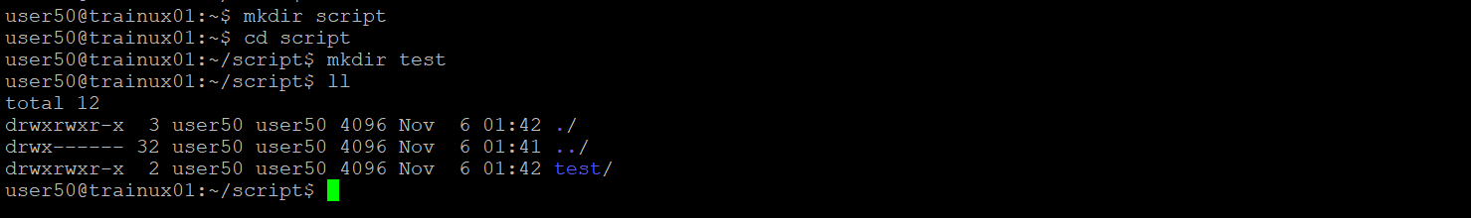

4. Change to “test” directory. Run the script “myscript” [Hint: You will have to update PATH to include the directory containg script to run script from any location]. – **cd test**

**export PATH=$PATH:..**